***Solution Section* 1.7 - Modeling Population Growth**

***Exercise***

The rate of growth of bacteria in a petri dish is proportional to the number of bacteria in the dish.

***Solution***



***Exercise***

The rate of growth of a population of field mice is inversely proportional to the square root of the population.

***Solution***



***Exercise***

A biologist starts with 100 *cells* in a culture. After 24 *hrs,* he counts 300. Assuming a Malthusian model, what the reproductive rate? What will be the number of cells of the end of 5 *days*?

***Solution***



 **24 *hrs =* 1 *day P =* 300**













***Exercise***

A biologist prepares a culture. After 1 *day* of growth, the biologist counts 1000 cells. After 2*days,* he counts 3000. Assuming a Malthusian model, what the reproductive rate and how many cells were present initially?

***Solution***

***Given***: 

The equation of the Malthusian model is 

































***Exercise***

A population of bacteria is growing according to the Malthusian model. If the population is triples in 10 *hrs*, what is the reproduction rate? How often does the population double itself?

***Solution***









 



***Exercise***

Consider a lake that is stocked with walleye pike and that the population of pike is governed by the logistic equation



where time is measured in days and *P* in thousands of fish. Suppose that fishing is started in this lake and that 100 fish are removed each day.

***Solution***

1. Modify the logistic model to account for the fishing.

The modified logistic model





1. Find and classify the equilibrium points for your model.

 *Multiply 100 each term*



 *Solve for P*



 Asymptotically stable

 Unstable

1. Use qualitative analysis to completely discuss the fate of the fish population with this model. In particular, if the initial fish population is 1000, what happens to the fish as time passes? what will happen to an initial population having 2000 fish?

 

For the 1000 (= 1) population, the population decreases until it dies out (doomed);

For the 2000 (= 2) population, the population tend towards the equilibrium 





***Exercise***

Suppose that in 1885 the population of a certain country was 50 *million* and was growing at the rate of 750,000 people per year at that time. Suppose also that in 1940 its population was 100 *million* and was then growing at the rate of 1 *million* per year. Assume that this population satisfies the logistic equation. Determine both the limiting population *M* and the predicted population for the year 2000.

***Solution***





















 



***Exercise***

The time rate of change of a rabbit population *P* is proportional to the square root of *P*. At time  (months) the population numbers 100 rabbits and is increasing at the rate of 20 rabbits per month. How many rabbits will there be one year later?

***Solution***

***Given***: 

















***Exercise***

Suppose that the fish population  in a lake is attacked by a disease at time , with the result that the fish cease to reproduce (so that the birth rate is ) and the death rate *δ* (deaths per week per fish) is thereafter proportional to . If there were initially 900 fish in the lake and 441 were left after 6 weeks, how long did it take all the fish in the lake to die?

***Solution***

***Given***: 

















It will take 20 weeks for the fish to die in the lake.

***Exercise***

Suppose that when a certain lake is stocked with fish, the birth and death rates *β* and *δ* are both inversely proportional to 

1. Show that , where *k* is a constant.
2. If  and after 6 months there are 169 fish in the lake, how many will there be after 1 year?

***Solution***

1. 













1. ***Given***: 









There are 256 fish after 1 year.

***Exercise***

The time rate of change of an alligator population *P* in a swamp is proportional to the square of *P*. The swamp contained a dozen alligators in 1988, two dozen in 1998.

1. When will there be four dozen alligators in the swamp?
2. What happens thereafter?

***Solution***

***Given***: 

1. 

























, that is, in the year 2003

1. 

The population approaches infinity as *t* approaches 20 years.

***Exercise***

Consider a prolific breed of rabbits whose birth and death rates, *β* and *δ*, are each proportional to the rabbit population , with 

1. Show that 

Note that . This is doomsday

1. Suppose that  and that there are nine rabbits after ten months. When does doomsday occur?
2. With , repeat part (*a*)
3. What now happens to the rabbit population in the long run?

***Solution***

1. If the birth & death both are proportional to  with 















1. 

***Given***: 











 (doomsday)

1. If the birth & death both are proportional to  with 













1. 

Therefore , so the population die out in the long run.

***Exercise***

Consider a population  satisfying the logistic equation , where  is the time rate at which births occur and  is the rate at which deaths occur.

1. If the initial population is , and  births per month and  deaths per month are occurring at time , show that the limiting population is .
2. If the initial population is 120 rabbits and there are 8 births per month and 6 deaths per month occurring at time , how many months does it take for  to reach 95% of the limiting population *M*?
3. If the initial population is 240 rabbits and there are 9 births per month and 12 deaths per month occurring at time , how many months does it take for  to reach 105% of the limiting population *M*?

***Solution***

1.  



 ***√***

1. ***Given***: 





 





For 













1. ***Given***: 



 





For 













***Exercise***

The amount of drug in the blood of a patient (in *mg*) due to an intravenous line is governed by the initial value problem



Where *t* is measured in hours

1. Find and graph the solution of the initial value problem.
2. What is the steady-state level of the drug?
3. When does the drug level reach 90% of the steady-state value?

***Solution***

|  |  |
| --- | --- |
|  |  |

1. The steady-state level is



1. 











***Exercise***

A fish hatchery has 500 *fish* at time , when harvesting begins at a rate of *b* *fish/yr*. where . The fish population is modeled by the initial value problem.



Where *t* is measured in years.

1. Find the fish population for  in terms of the harvesting rate *b*.
2. Graph the solution in the case that . Describe the solution.
3. Graph the solution in the case that . Describe the solution.

***Solution***

1. 











|  |  |  |
| --- | --- | --- |
| 1. For | |  |
| 1. For |  | |

***Exercise***

A community of hares on an island has a population of 50 when observations begin at . The population for  is modeled by the initial value problem.



1. Find the solution of the initial value problem.
2. What is the steady-state population?

***Solution***

1. 























1. 



***Exercise***

When an infected person is introduced into a closed and otherwise healthy community, the number of people who become infected with the disease (in the absence of any intervention) may be modeled by the logistic equation



Where *k* is a positive infection rate, *A* is the number of people in the community, and  is the number of infected people at . The model assumes no recovery or intervention.

1. Find the solution of the initial value problem in terms of *k*, *A*, and .
2. Graph the solution in the case that  .
3. For fixed values of *k* and *A*, describe the long-term behavior of the solutions for any  with 

***Solution***

1. 





















|  |  |
| --- | --- |
|  |  |

1. 



 Which is the ***steady-state*** solution

***Exercise***

The reaction of chemical compounds can often be modeled by differential equations. Let  be the concentration of a substance in reaction for  (typical units of *y* are *moles/L*). The change in the concentration of a substance, under appropriate conditions, is , where  is a rate constant and the positive integer *n* is the order of the reaction.

1. Show that for a first-order reaction , the concentration obeys an exponential decay law.
2. Solve the initial value problem for a second-order reaction  assuming 
3. Graph and compare the concentration for a first-order and second-order reaction with  and 

***Solution***

1. 





1. 

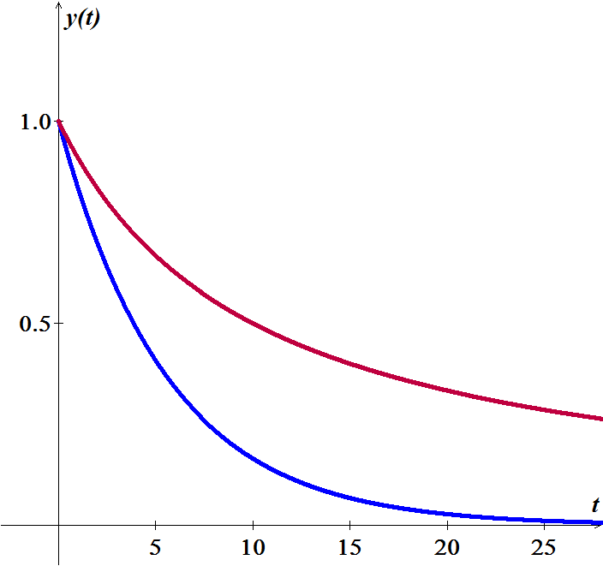









1. 





***Exercise***

The growth of cancer turmors may be modeled by the Gomperts growth equation. Let  be the mass of the tumor for . The relevant intial value problem is



Where *a* and *K* are positive constants and 

1. Graph the growth rate function  assuming  and . For what values of *M* is the growth rate positive? For what values of *M* is maximum?
2. Solve the initial cvalue problem and graph the solution for , , and . Describe the groath pattern of the tumor. Is the growth unbounded? If not, what is the limiting size of the tumor?
3. In the general equation, what is the meaning of *K*?

***Solution***

1. 



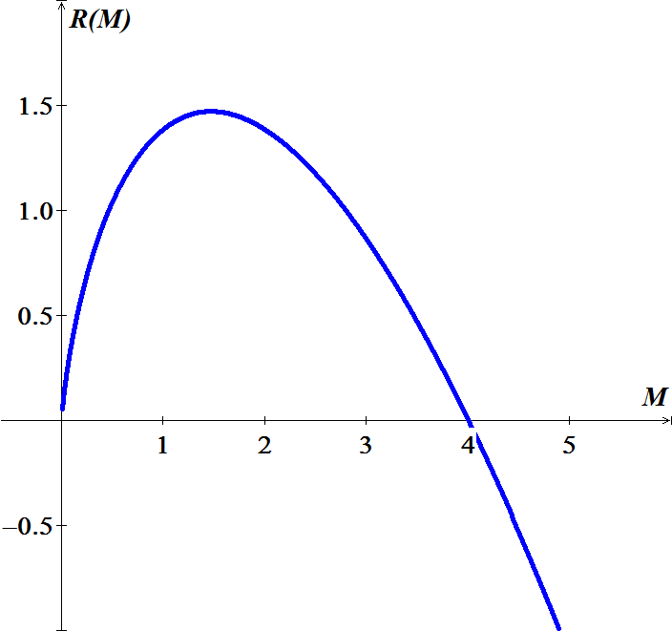

For  and 



1. 











For , , and 







So the limiting size of the tumor is 4.

1.  since 



***Exercise***

The halibut fishery has been modeled by the differential equation



Where  is the biomass (the total mass of the members of the population) in kilograms at time *t* (measured in years), the carrying capacity is estimated to be  and .

1. If , find the biomass a year later.
2. How long will it take for the biomass to reach .

***Solution***

1. 













 

















1. 













***Exercise***

Suppose a population  satisfies 

Where *t* is measured in years.

1. What is the carrying capacity?
2. What is ?
3. When will the population reach 50% of the carrying capacity?

***Solution***

1. 

































The carrying capacity is 400.

1. 





1. 











***Exercise***

The board of directors of a corporation is calculating the price to pay for a business that is forecast to yield a continuous flow of profit of $500,000 per year. The money will earn a nominal rate of 5% per year compounded continuously. What is the present value of the business?

1. For 20 years?
2. Forever (in perpetuity)?

***Solution***







1. 



1. 



***Exercise***

The population of a community is known to increase at a rate proportional to the number of people present at a time *t*. If the population has doubled in 6 *years*, how long it will take to triple?

***Solution***









***Exercise***

Let population of country be decreasing at the rate proportional to its population. If the population has decreased to 25% in 10 *years*, how long will it take to be half?

***Solution***









***Exercise***

Suppose that we have an artifact, say a piece of fossilized wood, and measurements show that the ratio of *C*−14 to carbon in the sample is 37% of the current ratio. Let us assume that the wood died at time 0, then compute the time *T* it would take for one gram of the radioactive carbon to decay this amount.

***Solution***

The half-life of carbon C-14 is about 5550.









***Exercise***

A certain radioactive material is known to decay at a rate proportional to the amount present. If initially there is  of the material present and after 2 *hours* it is observed that the material has lost 10% of its original mass, find

1. An expression for the mass of the material remaining at any time *t*.
2. The mass of the material after 4 *hours*
3. The time at which the material has decayed to one half of its initial mass.

***Solution***

1. 























1. 



1. 



***Exercise***

The rate at which radioactive nuclei decay is proportional to the number of such nuclei that are present in given sample. Half of the original number of radioactive nuclei have undergone disintegration in a period of 1,500 *years*.

1. What percentage of the original radioactive nuclei will remain after 4,500 *years*?
2. In how many years will only one-tenth of the original number remain?

***Solution***

1. 









 





The percentage of the original radioactive nuclei will remain after 4,500 *years*: 

1. 

 



***Solution Section* 1.8 - Basic Electrical Circuit**

***Exercise***

Sum the currents at each node in he circuit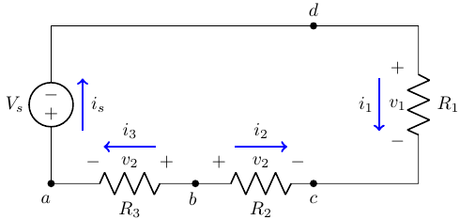

***Solution***









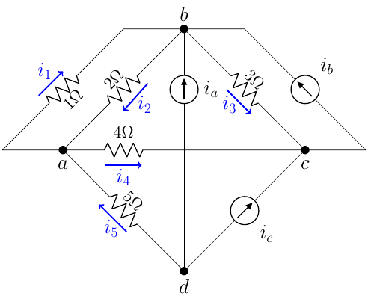***Exercise***

Sum the currents at each node in he circuit

***Solution***









***Exercise***

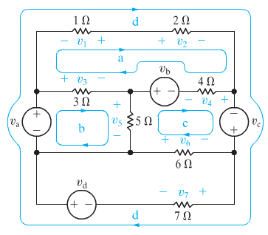Sum the voltges around rach designated path in the circuit

***Solution***









***Exercise***

A resistor  and a capacitor of  are joined in series with an electronic force (emf)  and no charge on the capacitor at . Find the ensuing charge on the capacitor at time *t* for the given 

***Solution***

 







|  |  |  |
| --- | --- | --- |
|  |  |  |
| + |  |  |
| − |  |  |
| + |  |  |















***Exercise***

A resistor  and a capacitor of  are joined in series with an electronic force (emf)  and no charge on the capacitor at . Find the ensuing charge on the capacitor at time *t* for the given 

***Solution***

 



















***Exercise***

A resistor  and a capacitor of  are joined in series with an electronic force (emf)  and no charge on the capacitor at . Find the ensuing charge on the capacitor at time *t* for the given 

***Solution***

 



















***Exercise***

A resistor  and a capacitor of  are joined in series with an electronic force (emf)  and no charge on the capacitor at . Find the ensuing charge on the capacitor at time *t* for the given 

***Solution***

 







|  |  |  |
| --- | --- | --- |
|  |  |  |
| + |  |  |
| **−** |  |  |
| + |  |  |















***Exercise***

An inductor  and a resistor  are joined in series with an electronic force (emf)  and no charge on the capacitor at . Find the ensuing charge current in the current at time *t* for the given 

***Solution***

 















***Exercise***

An inductor  and a resistor  are joined in series with an electronic force (*emf*)  and no charge on the capacitor at . Find the ensuing current in the current at time *t* for the given 

***Solution***

 





|  |  |  |
| --- | --- | --- |
|  |  |  |
| + |  |  |
| **−** |  |  |
| + |  |  |













***Exercise***

An inductor  and a resistor  are joined in series with an electronic force (*emf*)  and no charge on the capacitor at . Find the ensuing current in the current at time *t* for the given 

***Solution***

 





|  |  |  |
| --- | --- | --- |
|  |  |  |
| + |  |  |
| − |  |  |
| + |  |  |

















***Exercise***

An *RL* circuit with a  resistor and a  inductor is driven by a voltage . If the initial inductor current is zero, determine the subsequence resistor and inductor current and the voltages.

***Solution***

 













|  |  |  |
| --- | --- | --- |
|  |  |  |
| **+** |  |  |
| **−** |  |  |
| **+** |  |  |











The voltage at the resistor:



The voltage at the inductor:





***Exercise***

An *RL* circuit with a  resistor and a  inductor is driven by a voltage . If the initial inductor current is zero, determine the subsequence resistor and inductor current and the voltages.

***Solution***

 







|  |  |  |
| --- | --- | --- |
|  |  |  |
| **+** |  |  |
| **−** |  |  |
| **+** |  |  |















The voltage at the resistor:



The voltage at the inductor:





***Exercise***

An *RL* circuit with a  resistor and a  inductor is driven by a voltage . If the initial inductor current is 1 *A*, determine the subsequence resistor and inductor current and the voltages.

***Solution***

 



















|  |  |  |
| --- | --- | --- |
|  |  |  |
| **+** |  |  |
| **−** |  |  |
| **+** |  |  |





The voltage at the resistor:



The voltage at the inductor:





***Exercise***

An *RC* circuit with a  resistor and a  capacitor is driven by a voltage . If the initial capacitor current is zero, determine the subsequence resistor and capacitor current and the voltages.

***Solution***

 







|  |  |  |
| --- | --- | --- |
|  |  |  |
| **+** |  |  |
| **−** |  |  |
| **+** |  |  |













The voltage across the capacitor is:



The current is:





The voltage across the resistor is:



***Exercise***

Solve the general initial value problem modeling the *RC* circuit 

Where *E* is a constant source of *emf*

***Solution***















***Exercise***

Solve the general initial value problem modeling the *LR* circuit 

Where *E* is a constant source of emf

***Solution***





















***Exercise***

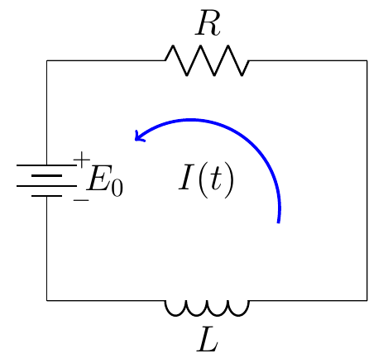For the given *RL*−circuit

Where  is a constant source of *emf* at time .

Find the current  flowing in the circuit.

***Solution***





















***Exercise***

For the given *RL*−circuit, wWhere  is the impressed voltage.

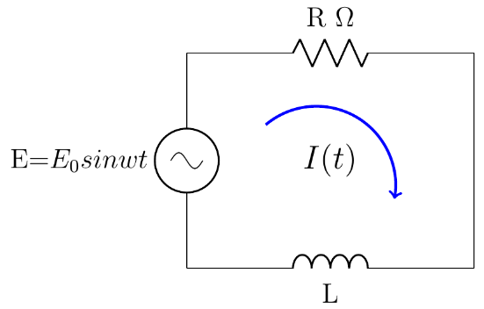Find the current  flowing in the circuit.

***Solution***















|  |  |  |
| --- | --- | --- |
|  |  |  |
| + |  |  |
| − |  |  |
| + |  |  |









***Exercise***

For the given *RL*−circuit

Which has a constant impressed voltage *E*, a resistor of resistance *R*, and a coil of impedance *L*.

Find the current  flowing in the circuit.

***Solution***

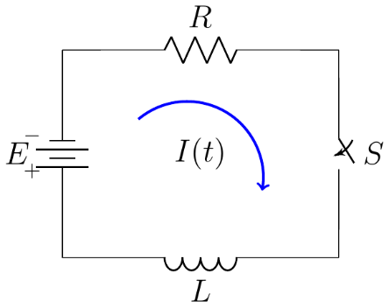























***Exercise***

For the given *RL*−circuit

Which has a constant impressed voltage *E*, a resistor of resistance *R*, and a coil of impedance *L*.

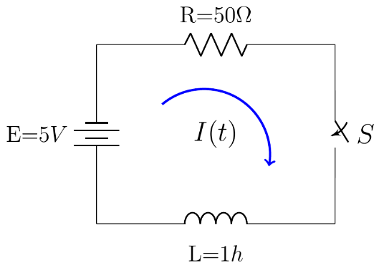Find the current  flowing in the circuit.

***Solution***

















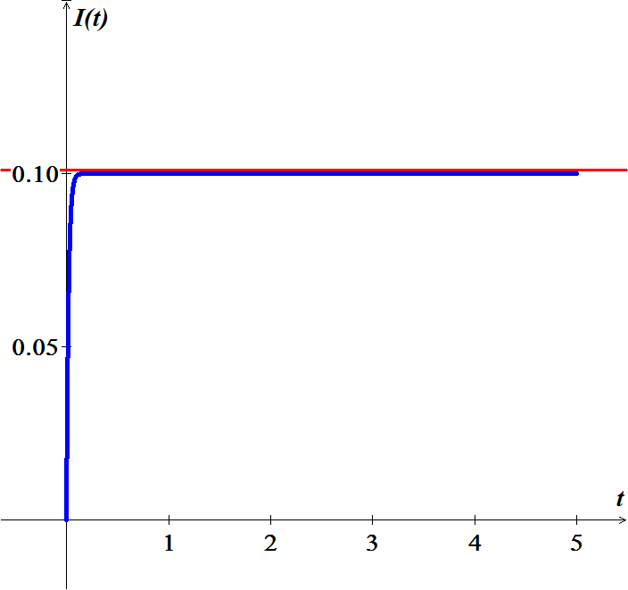

***Exercise***

Consider the circuit shown and let , , and  be the currents through the capacitor, resistor, and inductor, respectively. Let , , and  be the corresponding voltage drops. The arrows denote the arbitrary chosen directions in which currents and voltage drops will be taken to be positive.

1. Applying Kirchhoff’s second law to the upper loop in the circuit, show that



1. Applying Kirchhoff’s first law to either node in the circuit, show that 
2. Use the current-voltage relation through each element in the circuit to obtain the equations



1. Eliminate , ,  and to obtain 

***Solution***

1. Taking the clockwise loop around each paths, it is easy to see that voltage drops are given by



1. 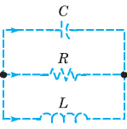Consider the right node. The current is given by . The current leaving the node is . Hence the cursing through the node is .

Based on Kirchhoff’s first law, 

1. In the capacitor 

In the resistor 

In the inductor 

1. Based on part (a), . Based on part (*b*),



It follows: 

***Exercise***

Consider the circuit. Use the method outlined to show that the current *I* through the inductor and the voltage *V* across the capacitor satisfy the system of differential equations.



***Solution***

let , ,  and  be the current through the resistors, inductor, and capacitor, respectively.

Assign , ,  and  to be the corresponding voltage drops.

Based on Kirchhoff’s second law, the net voltage drops, around each loop, satisfy



Applying Kirchhoff’s first law:

Node ***a***: 

Node ***b***: 

Node ***c***: 



Using the current-voltage relations:

 

 





Let 





***Exercise***

Consider an electric circuit containing a capacitor, resistor, and battery.

The charge  on the capacitor satisfies the equation



Where *R* is the resistance, *C* is the capacitance, and *V* is the constant voltage supplied by the battery.

1. If , find  at time *t*.
2. Find the limiting value  that approaches after a long time.
3. Suppose that  and that at time  the battery is removed and the circuit is closed again. Find  for .

***Solution***

1. 

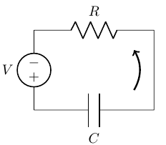 























1. 

 



1. In this case, , 







The solution is 

So, 









***Exercise***

A circuit containing an electromotive force, a capacitor with a capacitance of *C* farads (*F*), and a resistor with a resistance of *R* ohms . The voltage drop across the capacitor is , where *Q* is the charge (in coulombs), so in this case ***Kirchhoff’s Law*** gives



But , so we have 

Find the charge and the current at time *t*

1. Suppose the resistance is , the capacitance is 0.05 *F*, a battery gives voltage of 60 *V* and initial charge is 
2. Suppose the resistance is , the capacitance is 0.01 *F*,  and initial charge is 

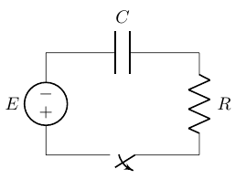***Solution***

1. 















1. 







|  |  |  |
| --- | --- | --- |
|  |  |  |
| **+** |  |  |
| **−** |  |  |
| **+** |  |  |



















***Exercise***

A heart pacemaker consists of a switch, a battery voltage , a capacitor with constant capacitance *C*, and the heart as a resistor with constant resistance *R*. When the switch is closed, the capacitor charges; when the switch is open, the capacitor discharges, sending an electrical stimulus to the heart. During the time the heart is being stimulated, the voltage *E* across the heart satisfies the linear differential equation



Solve the *DE*, subject to 

***Solution***















***Exercise***

A 30−volt electromotive force is applied to an *LR*-series circuit in which the inductance is 0.1 *henry* and the resistance is 50 *ohms*.

1. Find the current  if 
2. Determine the current as 
3. Solve the equation when  and 

***Solution***

1.  







 

|  |  |  |
| --- | --- | --- |
|  |  |  |
| **+** |  |  |
| **−** |  |  |
| **+** |  |  |





1. 



1. 









 





***Exercise***

A 100−volt electromotive force is applied to an *RC*-series circuit in which the resistance is 200 *ohms* and the capacitance is  *farad*.

1. Find the charge  if 
2. Find the current as 

***Solution***

***Given***: 

1.  

















1.  

***Exercise***

A 200−volt electromotive force is applied to an *RC*-series circuit in which the resistance is 1000 *ohms* and the capacitance is  *farad*.

1. Find the charge  if 
2. Determine the charge as 

***Solution***

***Given***: 

1.  











 







1.  



***Exercise***

An electromotive force



Is applied to an *LR*-series circuit in which the inductance is 20 *henries* and resistance is 2 *ohms*. Find the current  if 

***Solution***

For 

 

















For 

 



















***Exercise***

Suppose an *RC*-series circuit has a variable resistor. If the resistance at time *t* is given by  where  and  are known positive constants, then



If  and , where  and  are constants, show that



***Solution***



























***Exercise***

A heart pacemaker, consists of a switch, a battery, a capacitor, and the heart as a resistor.

When the switch *S* is at *P*, the capacitor charges; when *S* is at *Q*, the capacitor discharges, sending an electrical stimulus to the heart. The electrical stimulus is being applied to the heart, the voltage *E* across the heart satisfies the linear DE.



1. Let assume that over the time interval of length , , the switch *S* is at position *P* and the capacitor is being charges. When the switch is moved to position *Q* at time  the capacitor discharges, sending an impulse to the heart over the time interval of length : . Thus over the initial charging/discharging interval the voltage to the heart is actually modeled by the piecewise-defined differential equation



By moving *S* between *P* and *Q*, the charging and discharging over time intervals of lengths  and  is repeated indefinitely. Suppose , . , and , , , , , and so on.

Solve for  for 

1. Suppose for the sake of illustration that . Graph the solution in part (*a*) for 

***Solution***

1. 

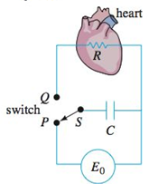





For , , and 



For 











1. 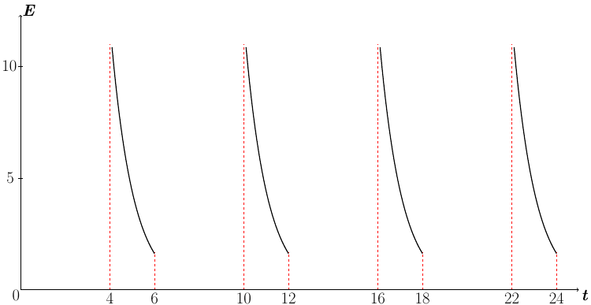

***Solution Section* 1.9 - Existence and Uniqueness of Solutions**

***Exercise***

Which of the initial value problems are guaranteed a unique solution. 

***Solution***

→ *f* is continuous

 is also continuous on the whole plane.

Hence the hypotheses are satisfied and guarantee a unique solution.

***Exercise***

Which of the initial value problems are guaranteed a unique solution? 

***Solution***





Initial condition: 

Both  are not continuous in the rectangle containing 

Hence the hypotheses are not satisfied.

***Exercise***

Which of the initial value problems are guaranteed a unique solution? 

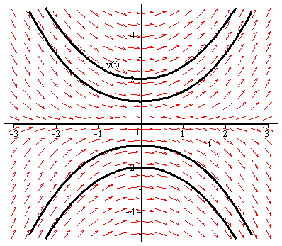***Solution***

The right hand side of the equation is , which is continuous in the whole plane.  is also continuous in the whole plane.

Hence the hypotheses are satisfied and the theorem guarantees a unique solution.

***Exercise***

Which of the initial value problems are guaranteed a unique solution? 

***Solution***

The right hand side of the equation is , which is continuous in the whole plane.

 is also continuous in the whole plane.

Hence the hypotheses are satisfied and the theorem guarantees a unique solution.

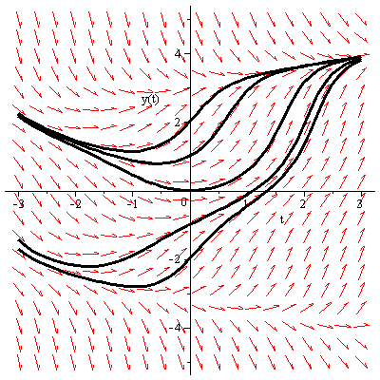

***Exercise***

Which of the initial value problems are guaranteed a unique solution? 

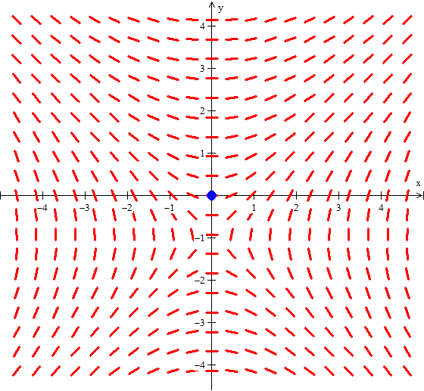***Solution***

The right hand side of the equation is , which is continuous in the whole plane, except where .

 is also continuous in the whole plane, except where .

Hence the hypotheses are satisfied in a rectangle containing the initial point (0, 0), so the theorem guarantees a unique solution.

***Exercise***

Which of the initial value problems are guaranteed a unique solution? 

***Solution***

The right hand side of the equation is , which is continuous in the whole plane, except where .

Since the initial point is (0, 1), *f* is discontinuous there.

Consequently there is no rectangle containing this point in which *f* is continuous.

The hypotheses are not satisfied, so the theorem doesn’t guarantee a unique solution.

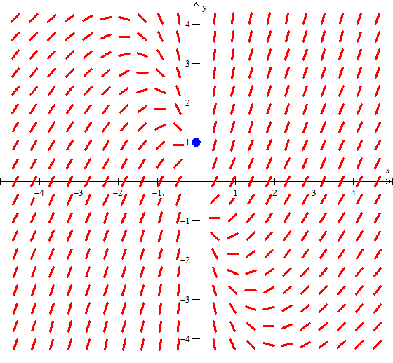

***Exercise***

Which of the initial value problems are guaranteed a unique solution? 

***Solution***

The right hand side of the equation is , which is continuous in the whole plane.

 is also continuous in the whole plane.

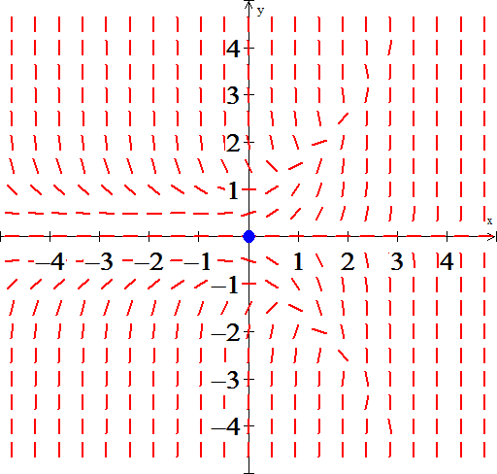 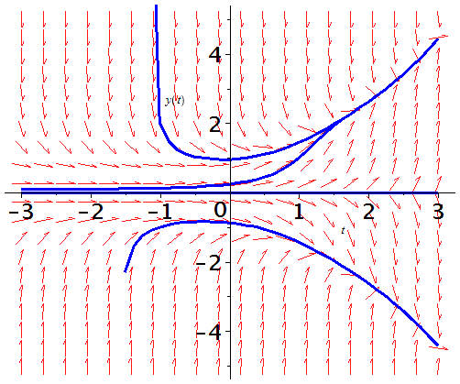

Hence the hypotheses are satisfied in a rectangle containing the initial point (0, 0), so the theorem guarantees a unique solution.

***Exercise***

Which of the initial value problems are guaranteed a unique solution? 

***Solution***

The right hand side of the equation is , which is continuous in the whole plane.

 is also continuous in the whole plane.

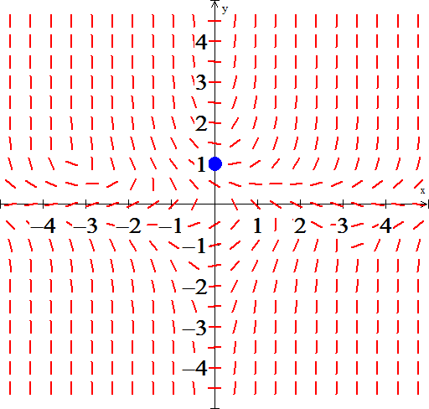 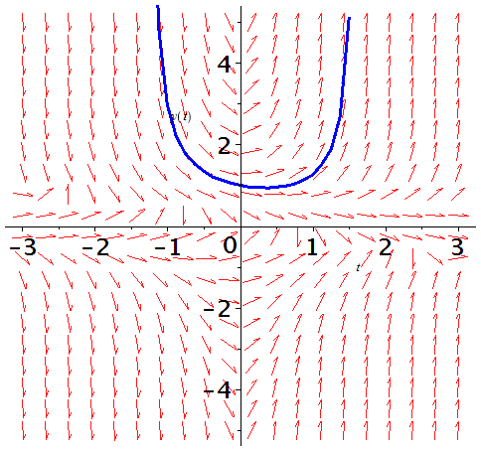

Hence the hypotheses are satisfied in a rectangle containing the initial point , so the theorem guarantees a unique solution.

***Exercise***

Which of the initial value problems are guaranteed a unique solution? 

***Solution***

The right hand side of the equation is , which is continuous in the whole plane.

 is also continuous in the whole plane.

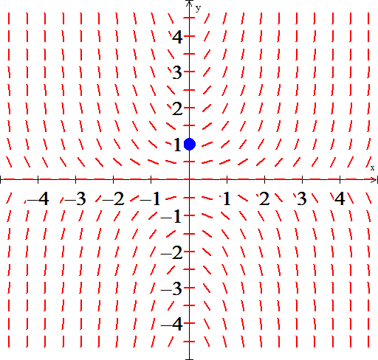 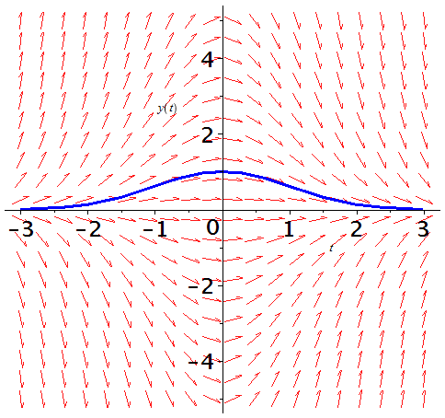

Hence the hypotheses are satisfied in a rectangle containing the initial point , so the theorem guarantees a unique solution.

***Exercise***

Which of the initial value problems are guaranteed a unique solution? 

***Solution***

The right hand side of the equation is , which is continuous in the whole plane, except where  .

 is also continuous in the whole plane, except where .

Since 

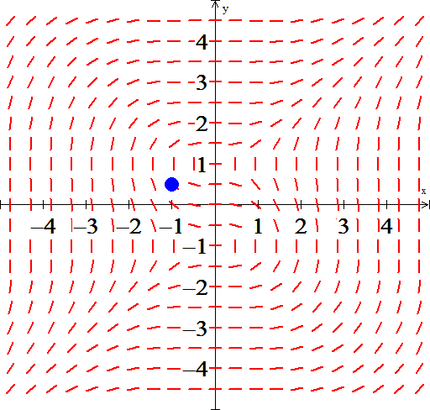 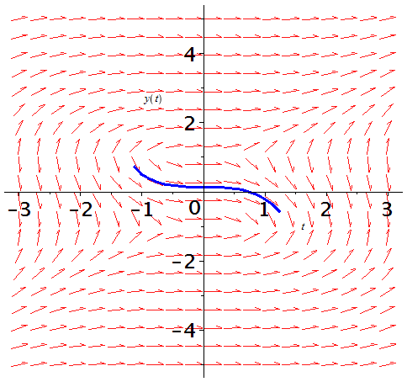

Hence the hypotheses are satisfied in a rectangle containing the initial point , so the theorem guarantees a unique solution.

***Exercise***

Which of the initial value problems are guaranteed a unique solution? 

***Solution***

The right hand side of the equation is , which is continuous in the whole plane, except where .

 is also continuous in the whole plane, except where 

Since 

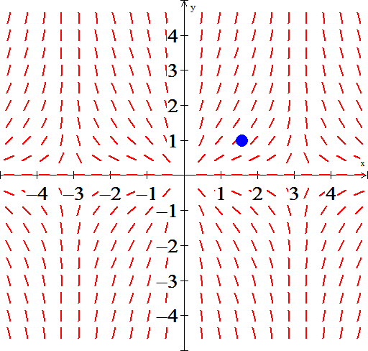 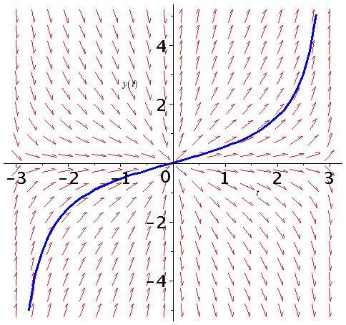

Hence the hypotheses are satisfied in a rectangle containing the initial point , so the theorem guarantees a unique solution.

***Exercise***

Which of the initial value problems are guaranteed a unique solution? 

***Solution***

The right hand side of the equation is , which is continuous in the whole plane except where .

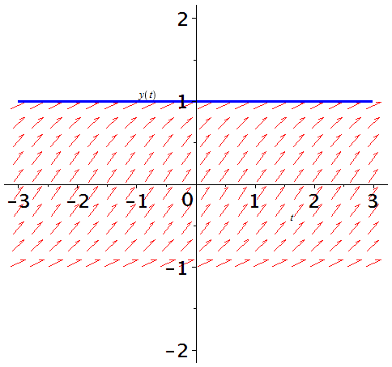 undefined.

So the uniqueness theorem doesn’t apply













***Exercise***

Show that and  are both solutions of the initial value problem , where . Explain why this fact doesn't contradict Theorem

***Solution***



whichis not continuous at 

***Exercise***

Use a numerical solver to sketch the solution of the given initial value problem



1. Where does your solver experience difficulty? why? Use the image of your solution to estimate the interval of existence.
2. Find an explicit solution; then use your formula to determine the interval of existence. How does it compare with the approximation found in part (*a*).

***Solution***

1. 

















Solve for *y*:







***b)*** The only solution is:  and 

The interval of the solution 

***Solution Section* 1.10 - Autonomous Equations and Stability**

***Exercise***

The graph of the right-hand side  is shown. Identify the equilibrium points and sketch the equilibrium solutions in the *ty*-plane. Classify each equilibrium point as either unstable or asymptotically stable.

***Solution***



The equilibrium point is:  and is stable

***Exercise***

The graph of the right-hand side  is shown. Identify the equilibrium points and sketch the equilibrium solutions in the *ty*-plane. Classify each equilibrium point as either unstable or asymptotically stable.

***Solution***



The equilibrium points are:  and both are unstable

***Exercise***

The graph of the right-hand side  is shown. Identify the equilibrium points and sketch the equilibrium solutions in the *ty*-plane. Classify each equilibrium point as either unstable or asymptotically stable.

***Solution***



The equilibrium points are: 

 are asymptotically stable

 are unstable

***Exercise***

Impose the equilibrium solution(s), classifying each as either unstable or asymptotically stable

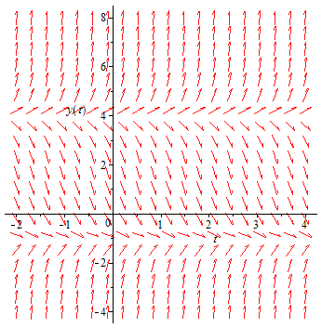

***Solution***

Because the  is autonomous, the slope at any point  in the direction field does not depend on *t*, only on *y*.

There are two equilibrium points. The smaller of them is unstable and the other is asymptotically stable.

***Exercise***

An autonomous differential equation is given by 

1. Sketch a graph of 
2. Use the graph of *f* to develop a phase line for the autonomous equation. Classify each equilibrium point as either unstable or asymptotically stable.
3. Sketch the equilibrium solutions in the *ty*-plane into regions. Sketch at least one solution trajectory in each of these regions.

***Solution***

1. 

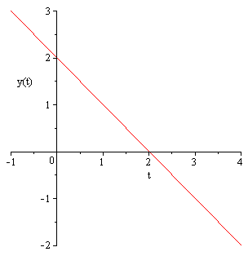

1. The phase line for the autonomous equation is



 is asymptotically stable

1. The phase line indicates that the solutions increase if *y* < 2 and decrease if *y* > 2.

The stable equilibrium solution is 

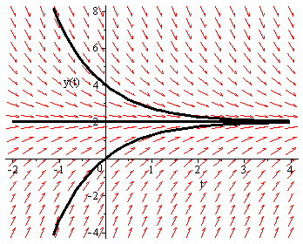

***Exercise***

An autonomous differential equation is given by 

1. Sketch a graph of 
2. Use the graph of *f* to develop a phase line for the autonomous equation. Classify each equilibrium point as either unstable or asymptotically stable.
3. Sketch the equilibrium solutions in the *ty*-plane into regions. Sketch at least one solution trajectory in each of these regions.

***Solution***

1. 



1. The phase line for the autonomous equation is

-1 4

 is asymptotically stable and  is unstable

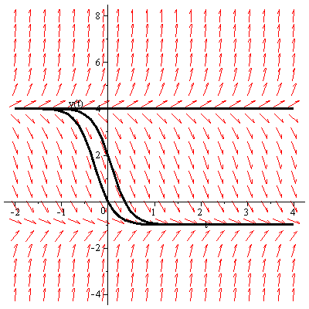

***Exercise***

An autonomous differential equation is given by 

1. Sketch a graph of 
2. Use the graph of *f* to develop a phase line for the autonomous equation. Classify each equilibrium point as either unstable or asymptotically stable.
3. Sketch the equilibrium solutions in the *ty*-plane into regions. Sketch at least one solution trajectory in each of these regions.

***Solution***

1. 



1. The phase line for the autonomous equation is



1. The solutions increase if *y* < −3, decrease for −3 < *y* < 0, increase if 0 < *y* < 3, and decrease for *y* > 3.

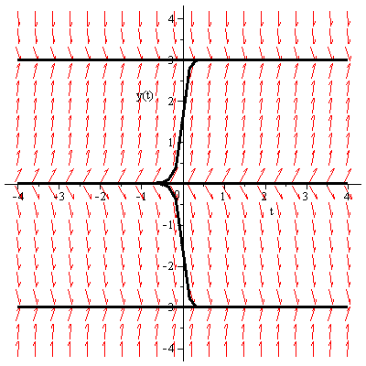

The stable equilibrium solutions at  and unstable equilibrium solutions at 

***Exercise***

An autonomous differential equation is given by 

1. Sketch a graph of 
2. Use the graph of *f* to develop a phase line for the autonomous equation. Classify each equilibrium point as either unstable or asymptotically stable.
3. Sketch the equilibrium solutions in the *ty*-plane into regions. Sketch at least one solution trajectory in each of these regions.

***Solution***

1. 



1. The phase line for the autonomous equation is



1. The solutions decrease if −π < *y* < 0, increase for 0 < *y* < π, increase if π < *y* < 2π

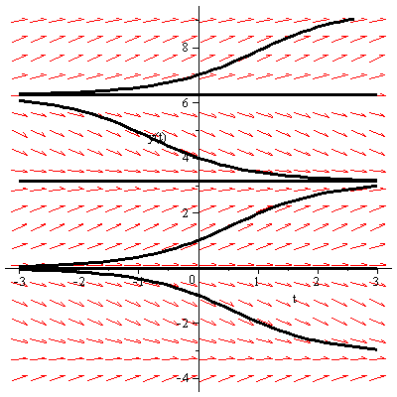

The stable equilibrium solutions at  and unstable equilibrium solutions at 

***Exercise***

An autonomous differential equation is given by 

1. Sketch a graph of 
2. Use the graph of *f* to develop a phase line for the autonomous equation. Classify each equilibrium point as either unstable or asymptotically stable.
3. Sketch the equilibrium solutions in the *ty*-plane into regions. Sketch at least one solution trajectory in each of these regions.

***Solution***

1. 

The critical points are 0 and 3.

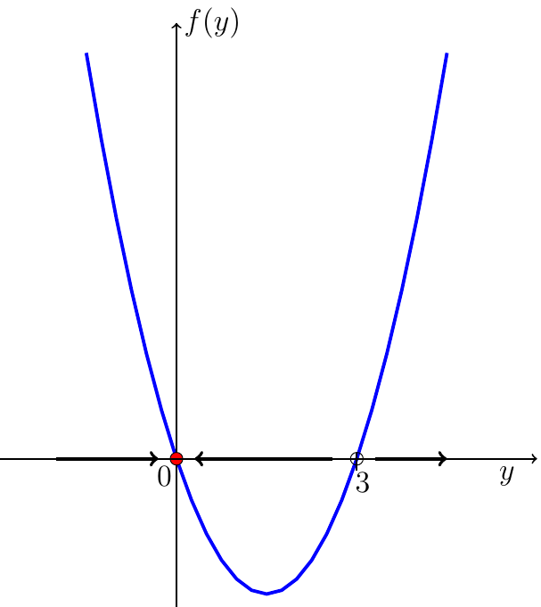

1. The phase line for the autonomous equation is

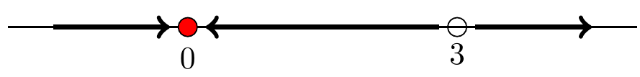

1. The solutions increase if  and , decrease 

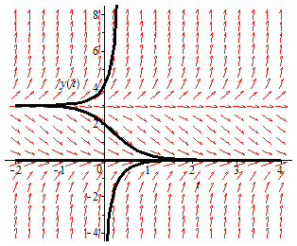

The asymptotically stable equilibrium solution at  (attractor) and unstable equilibrium solutions at  (repeller).

***Exercise***

An autonomous differential equation is given by 

1. Sketch a graph of 
2. Use the graph of *f* to develop a phase line for the autonomous equation. Classify each equilibrium point as either unstable or asymptotically stable.
3. Sketch the equilibrium solutions in the *ty*-plane into regions. Sketch at least one solution trajectory in each of these regions.

***Solution***

1. 

The critical points are 0 and 1.

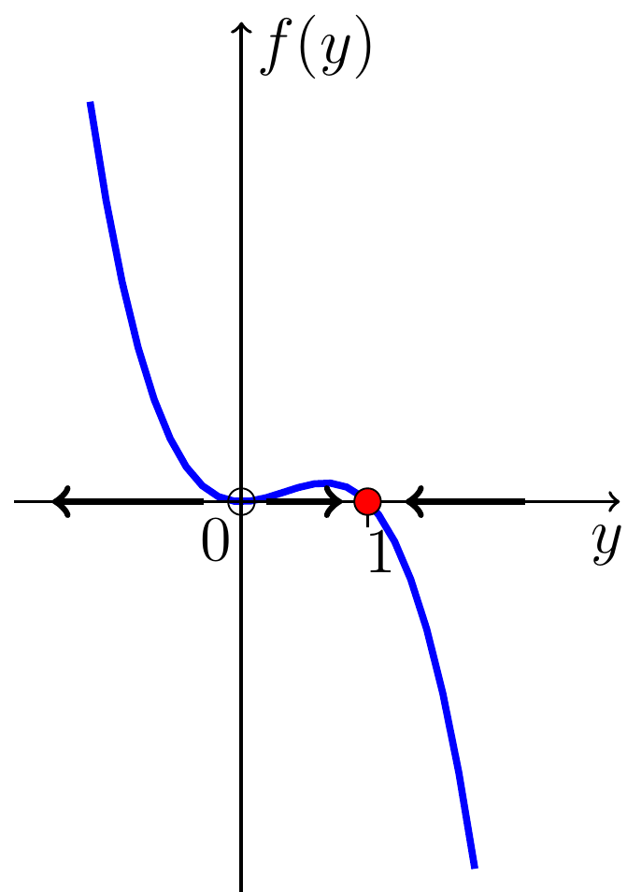

1. The phase line for the autonomous equation is

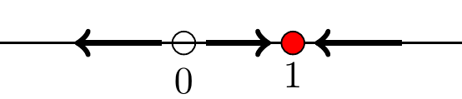

1. The solutions increase if  and , decrease 

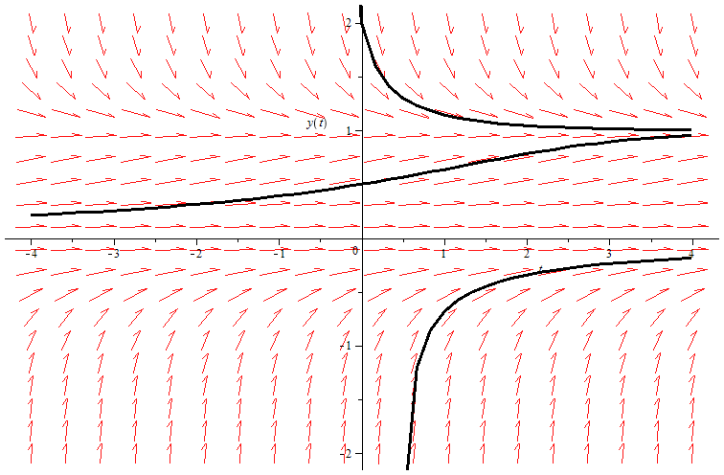

The asymptotically stable at  (attractor) and semi-stable at .

***Exercise***

An autonomous differential equation is given by 

1. Sketch a graph of 
2. Use the graph of *f* to develop a phase line for the autonomous equation. Classify each equilibrium point as either unstable or asymptotically stable.
3. Sketch the equilibrium solutions in the *ty*-plane into regions. Sketch at least one solution trajectory in each of these regions.

***Solution***

1. 

The critical point is 2.

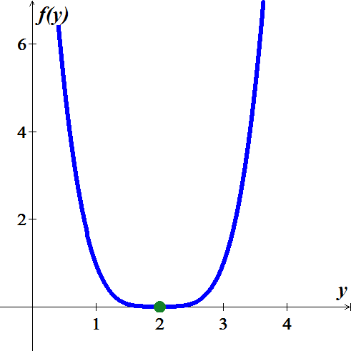

1. The phase line for the autonomous equation is

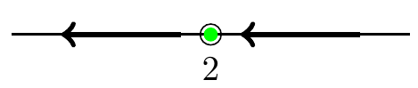

1. The solutions increase if  and 

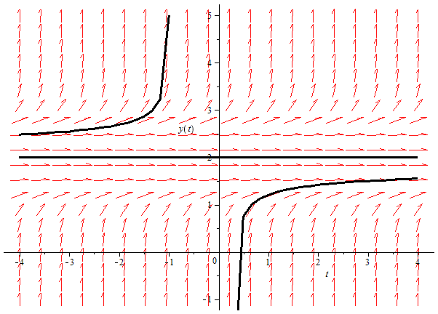

The semi-stable at .

***Exercise***

An autonomous differential equation is given by 

1. Sketch a graph of 
2. Use the graph of *f* to develop a phase line for the autonomous equation. Classify each equilibrium point as either unstable or asymptotically stable.
3. Sketch the equilibrium solutions in the *ty*-plane into regions. Sketch at least one solution trajectory in each of these regions.

***Solution***

1. 

The critical points are −2 and 5.

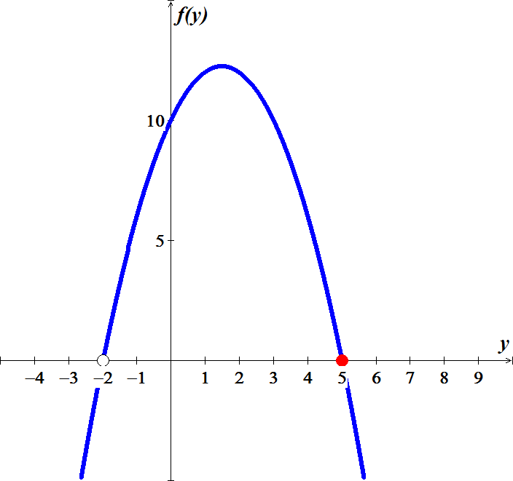

1. The phase line for the autonomous equation is

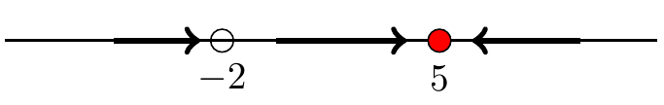

1. The solutions increase if , decrease  and 

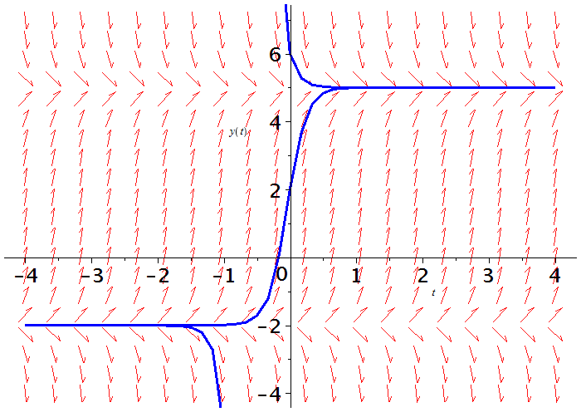

The asymptotically stable at  (attractor) and unstable at  (repeller).

***Exercise***

An autonomous differential equation is given by 

1. Sketch a graph of 
2. Use the graph of *f* to develop a phase line for the autonomous equation. Classify each equilibrium point as either unstable or asymptotically stable.
3. Sketch the equilibrium solutions in the *ty*-plane into regions. Sketch at least one solution trajectory in each of these regions.

***Solution***

1. 

The critical points are  and 0.

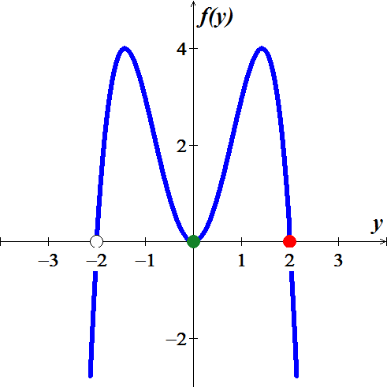

1. The phase line for the autonomous equation is

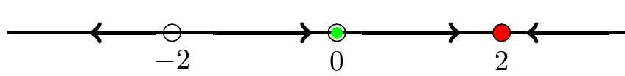

1. The solutions increase if , decrease  and 

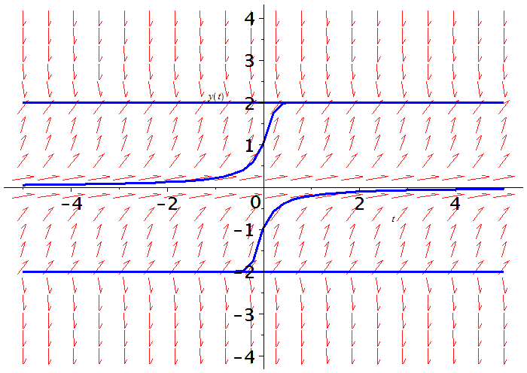

The asymptotically stable at  (attractor), semi-stable at , and unstable at  (repeller).

***Exercise***

An autonomous differential equation is given by 

1. Sketch a graph of 
2. Use the graph of *f* to develop a phase line for the autonomous equation. Classify each equilibrium point as either unstable or asymptotically stable.
3. Sketch the equilibrium solutions in the *ty*-plane into regions. Sketch at least one solution trajectory in each of these regions.

***Solution***

1. 

The critical points are .

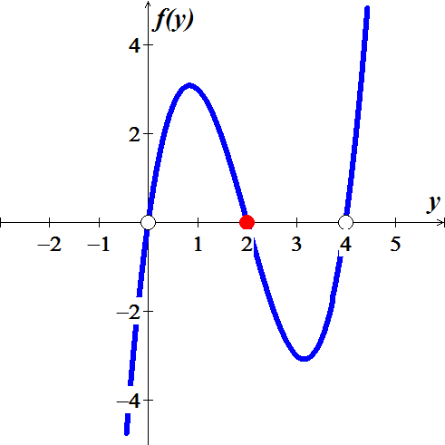

1. The phase line for the autonomous equation is

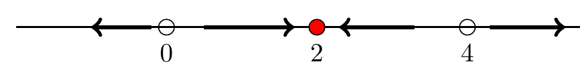

1. The solutions increase if  and , decrease  and 

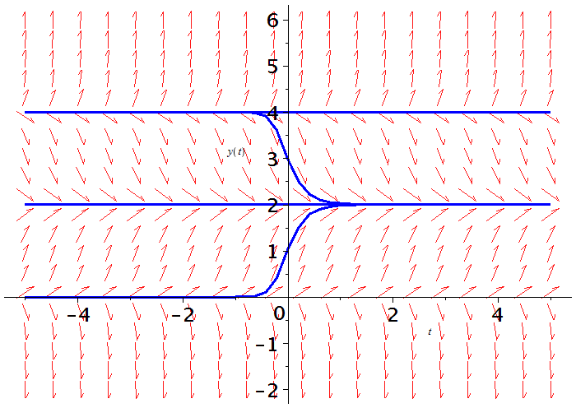

The asymptotically stable at  (attractor) and unstable at  (repellers).

***Exercise***

An autonomous differential equation is given by 

1. Sketch a graph of 
2. Use the graph of *f* to develop a phase line for the autonomous equation. Classify each equilibrium point as either unstable or asymptotically stable.
3. Sketch the equilibrium solutions in the *ty*-plane into regions. Sketch at least one solution trajectory in each of these regions.

***Solution***

1. 

The critical points are .

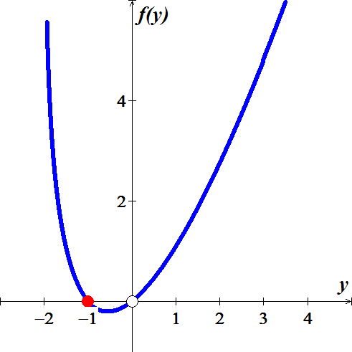

1. The phase line for the autonomous equation is

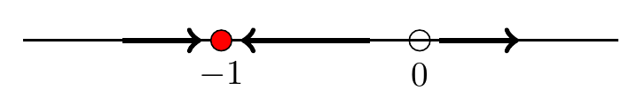

1. The solutions increase if  and , decrease 

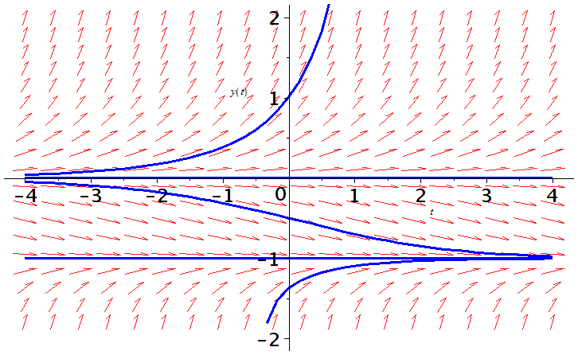

The asymptotically stable at  (attractor) and unstable at  (repeller).

***Exercise***

An autonomous differential equation is given by 

1. Sketch a graph of 
2. Use the graph of *f* to develop a phase line for the autonomous equation. Classify each equilibrium point as either unstable or asymptotically stable.
3. Sketch the equilibrium solutions in the *ty*-plane into regions. Sketch at least one solution trajectory in each of these regions.

***Solution***

1. 

The critical points are .

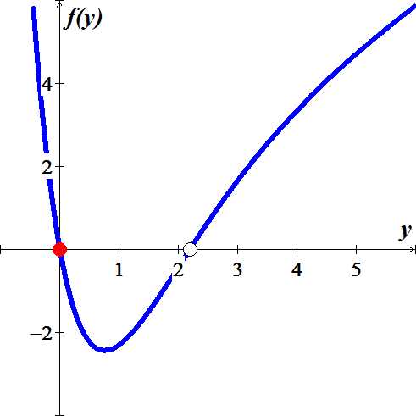

1. The phase line for the autonomous equation is

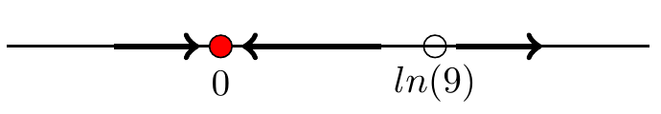

1. The solutions increase if  and , decrease 

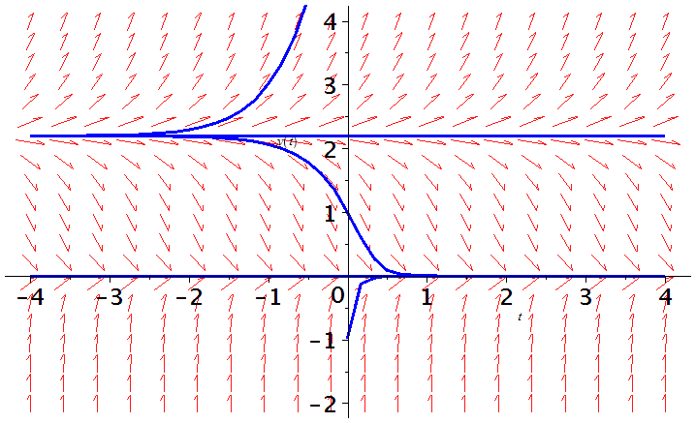

The asymptotically stable at  (attractor) and unstable at  (repeller).

***Exercise***

An autonomous differential equation is given by 

1. Sketch a graph of 
2. Use the graph of *f* to develop a phase line for the autonomous equation. Classify each equilibrium point as either unstable or asymptotically stable.
3. Sketch the equilibrium solutions in the *ty*-plane into regions. Sketch at least one solution trajectory in each of these regions.

***Solution***

1. 



The critical points are .

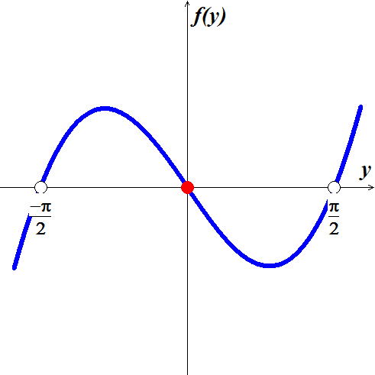

1. The phase line for the autonomous equation is

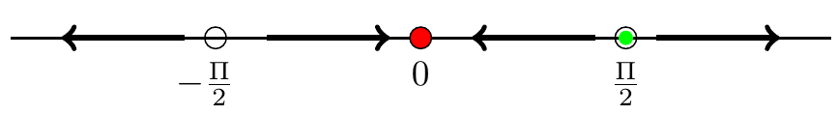

1. The solutions increase if  and , decrease  and 

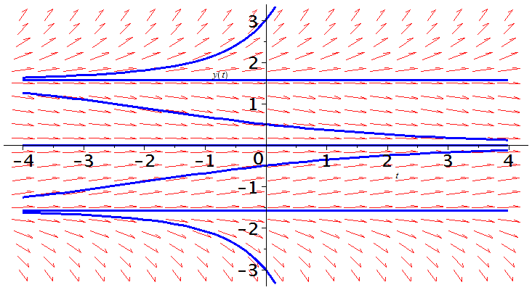

The asymptotically stable at  (attractor) and unstable at  (repeller).

***Exercise***

An autonomous differential equation is given by 

1. Sketch a graph of 
2. Use the graph of *f* to develop a phase line for the autonomous equation. Classify each equilibrium point as either unstable or asymptotically stable.
3. Sketch the equilibrium solutions in the *ty*-plane into regions. Sketch at least one solution trajectory in each of these regions.

***Solution***

1. 





The critical points are .

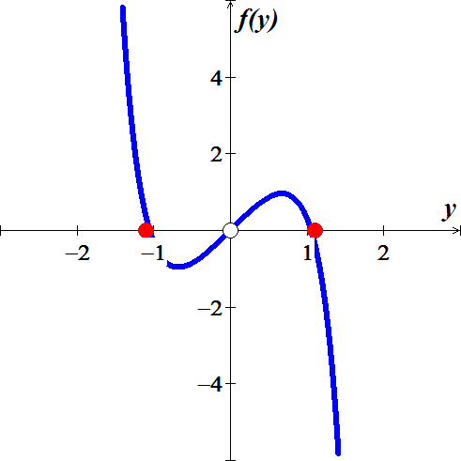

1. The phase line for the autonomous equation is

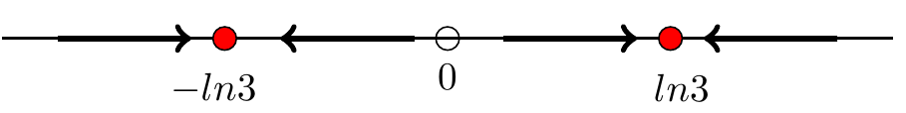

1. The solutions increase if  and , decrease  and 

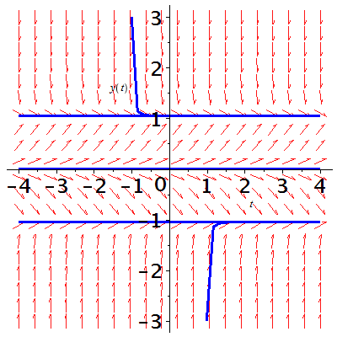

The asymptotically stable at  (attractor) and unstable at  (repeller).

***Exercise***

An autonomous differential equation is given by 

1. Sketch a graph of 
2. Use the graph of *f* to develop a phase line for the autonomous equation. Classify each equilibrium point as either unstable or asymptotically stable.
3. Sketch the equilibrium solutions in the *ty*-plane into regions. Sketch at least one solution trajectory in each of these regions.

***Solution***

1. 

The critical points are .

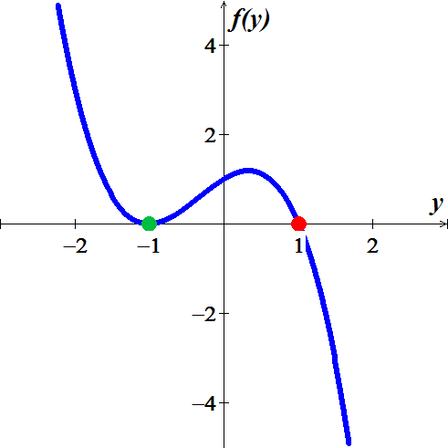

1. The phase line for the autonomous equation is

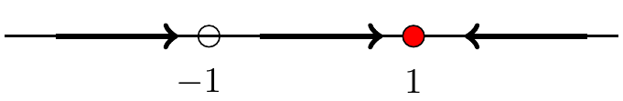

1. The solutions increase if  and , decrease 

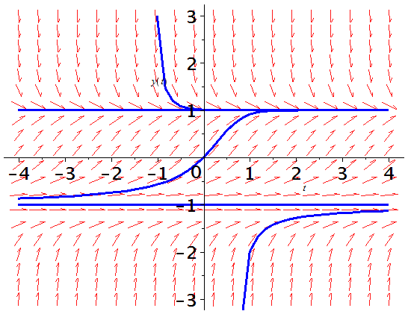

The asymptotically stable at  (attractor) and semi-stable at .

***Exercise***

An autonomous differential equation is given by 

1. Sketch a graph of 
2. Use the graph of *f* to develop a phase line for the autonomous equation. Classify each equilibrium point as either unstable or asymptotically stable.
3. Sketch the equilibrium solutions in the *ty*-plane into regions. Sketch at least one solution trajectory in each of these regions.

***Solution***

1. 

The critical points are .

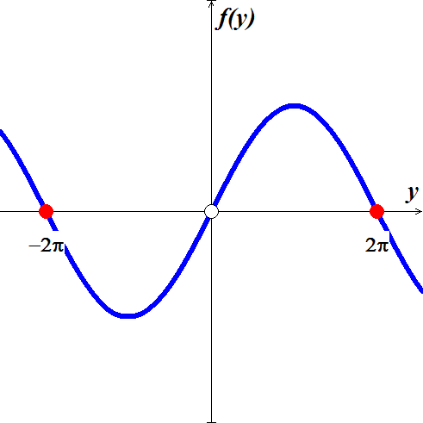

1. The phase line for the autonomous equation is

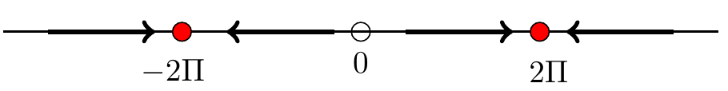

1. The solutions increase if  and , decrease  and 

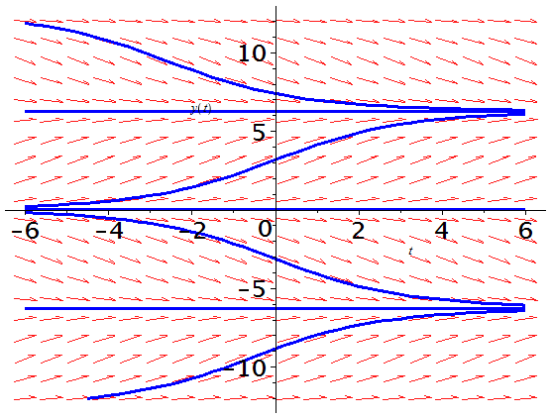

The asymptotically stable at  (attractor) and unstable at  (repeller).

***Exercise***

Determine the stability of the equilibrium solutions 

***Solution***





The equilibrium points 



  is unstable

  is asymptotically stable

***Exercise***

Determine the stability of the equilibrium solutions 

***Solution***

The equation .

 The equilibrium points are .





 ***Asymptotically stable***

 ***Unstable***

 ***Unstable***

***Exercise***

A tank contains 100 *gal* of pure water. A salt solution with concentration 3 *lb/gal* enters the tank at a rate of 2 *gal/min*. Solution drains from the tank at a rate of 2 *gal/min*. Use the qualitative analysis to find the eventual concentration of the salt in the tank.

***Solution***

Let  represents the amount of salt.







Let  represents the concentration of salt. Thus, 









 is stable equilibrium point so a trajectory should approach the stable equilibrium solution 

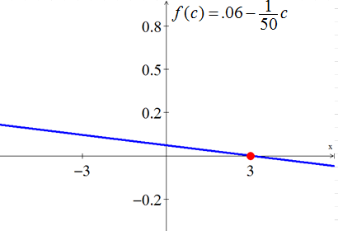

***Exercise***

A mathematical model for rate at which a drug disseminates into the bloodstream at time *t*.



Where *r* and *k* are positive constants. The function  describes the concentration of the drug in the bloodstream at time *t*.

1. Since the DE is autonomous, use the phase portrait concept to find the limiting value of  as 
2. Solve  subject to . Sketch the graph of  and verify your prediction in part (*a*). At what time is the concentration one-half this limiting value?

***Solution***

1. 

The equilibrium solution .

When 

When 



1. 









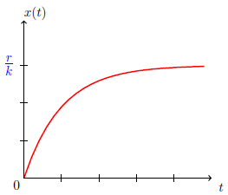 



 as 

If 







***Exercise***

When forgetfulness is taken into account, the rate of memorization of a subject is given by



Where , ,  is the amount memorized in time *t*, *M* is the total amount to be memorized, and  is the amount remaining to be memorized.

1. Since the DE is autonomous, use the phase portrait concept to find the limiting value of  as . Interpret the result
2. Solve  subject to . Sketch the graph of  and verify your prediction in part (*a*).

***Solution***

1. 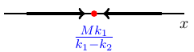



; the equilibrium solution



Since , the material will never be completely memorized and the larger is, the less the amount of material will be memorized over time.

1. 



















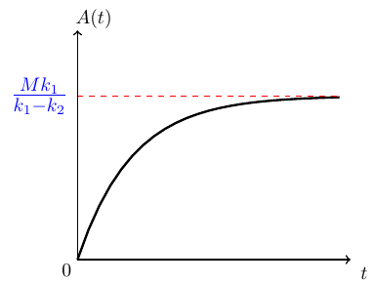

***Exercise***

The number  of supermarkets throughout the country that are using a computerized checkout system is described by the initial-value problem



1. Use the phase portrait concept to predict how many supermarkets are expected to adopt the new procedure over a long period of time. Sketch a solution curve of the given initial-value problem.
2. Solve the initial-value problem and then graph it to verify the solution in part (*a*)
3. How many companies are expected to adopt the new technology when ?

***Solution***

1. 



When 

From the phase portait:



1. 







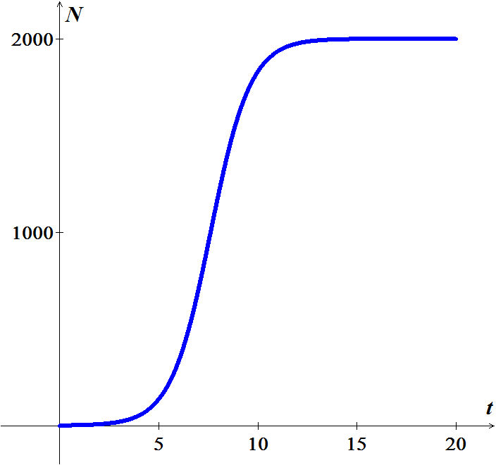



















About 1834 companies are expected to adopt the new technology when 

***Exercise***

For the linear *ODE* 

1. Find all solution of the given *DE* equation.
2. Show that the initial value , has exactly one solution.
3. But if  there is no solution at all. Why doesn’t this contradict the Existence and Uniqueness Theorem?
4. Plot several solutions of the *ODE* over the interval 

***Solution***

1. 











Each value of *C* gives 2 distinct solutions. On defined  and the other on 

1. ***Given***: 

, the only solution is when , which gives us the general solution



1. 

 which contradict the given information.

Which contradict the Existence and Uniqueness Theorem of the initial value existence.

1. The solution curve of  goes through the origin.

All the other are curves in the shape of hyperbolas and are asymptotic to one end or the other of the *y*-axis

